Feed the Future

Survey Implementation

Document

Pilot Protocol

Zone of Influence Survey

February 2018

This publication was prepared for review by the United States Agency for International Development. It was prepared for the Bureau for Food Security, United States Agency for International Development, USAID Contract Number GS-23F-8144H/AID-OAA-M-12-00006.

**Recommended Citation**

Jasbir Kaur and Wei-Cheng Chen. 2018.

*Feed the Future Zone of Influence Surveys: Pilot Protocol.*

Washington, DC: Bureau for Resilience and Food Security, USAID

**Contact Information**

Feed the Future

United States Agency for International Development

1300 Pennsylvania Ave, NW

Washington, DC 20004

[www.feedthefuture,gov](http://www.feedthefuture,gov)

Table of Contents

Introduction 1

Steps in the pilot 2

Step 1: Select the pilot location and determine the sample. 2

Step 2: Practice the field procedures required to collect the data. 2

Step 3: Debrief survey staff on problems encountered and discuss possible solutions. 3

Step 4: Revise the questionnaire or procedures, as needed, based on findings from the pilot. 4

Form I: Feedback form 5

Form II: Pilot interview observation checklist 6

# Introduction

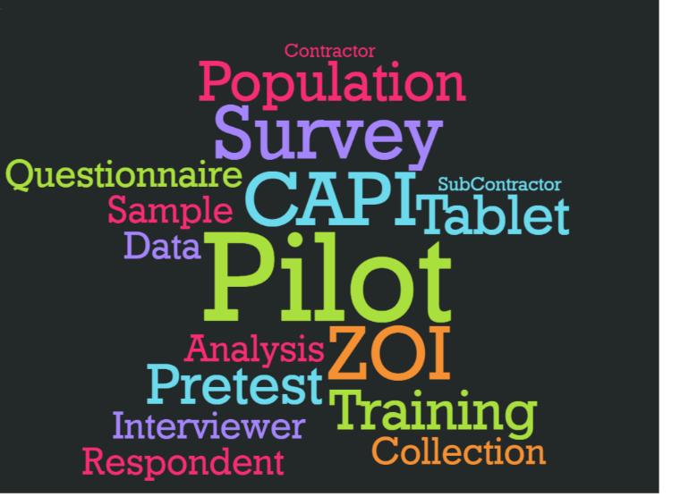Piloting survey fieldwork is one of the most significant parts of interviewer training. During the pilot, which is conducted under field conditions, the trainees will encounter many issues they may not see in the classroom. Field Supervisors and trainers can identify sections of the questionnaire or procedures that present problems for trainees during the pilot, which become evident through mistakes made during the exercise. It is therefore critical to plan and implement this small-scale trial to prepare for the Feed the Future Zone of Influence (ZOI) Survey. This protocol describes Feed the Future’s approach to piloting the ZOI Surveys.

The main purpose of the pilot is to run an end-to-end test of all survey procedures under field conditions and develop solutions for any issues that may arise. Field teams carry out comprehensive fieldwork procedures so that when the main fieldwork begins, they have more confidence and understanding of how the fieldwork should be implemented. The pilot will identify potential problems in training, logistics, communication, and data processing. It takes place after the classroom-based Interviewer training and before the main fieldwork starts, taking up to a week to complete, including traveling to the pilot areas, interviewing, and debriefing. Adequate time must be allowed for adjustments to be made based on the pilot’s findings before the main fieldwork begins.

Ideally, the pilot should be conducted in areas or communities similar to those the field teams will encounter during fieldwork, generally in agricultural communities; however, the pilot should not be conducted in clusters selected for main fieldwork. If appropriate, it can be helpful for the pilot to be accomplished in areas near the classroom training location: because the pilot is the first opportunity to practice computer-assisted personal interviewing (CAPI) data collection outside the classroom, issues may arise that require programmers and other IT staff to troubleshoot onsite.

All procedures defined for the main fieldwork are to be followed during the pilot. Interviews will be conducted using teams of two Interviewers. A male or a female Interviewer will interview male respondents, and a female interviewer will interview female respondents. Each interviewing team should complete six households, with each Interviewer taking the lead as Interviewer A to complete at least three households. Data will be collected using tablet computers to identify any problems in the CSPro CAPI data collection system or in data transmission among field team members (Interviewer to Interviewer, Interviewer to Field Supervisor, and Field Supervisor to the secure FTP server), keeping the tablets well-charged throughout the pilot, and troubleshooting unexpected technical issues with the data collection system.

# Steps in the pilot

The following steps are required to implement the pilot:

1. Select the pilot location and determine the sample.
2. Practice the field procedures required to collect the data.
3. Debrief survey staff on problems encountered and discuss possible solutions.
4. Revise the survey instrument or procedures, as needed, based on findings from the pilot.

The pilot provides field practice for the Interviewers, Field Supervisors, and Quality Control Supervisors. It also provides an opportunity to observe the preparedness of the interview teams in identifying the households sampled for the pilot test, making contact with the households, selecting eligible respondents, showing familiarity with the questionnaire, and transmitting data.

## Step 1: Select the pilot location and determine the sample.

The pilot should be conducted under realistic field conditions, in communities with cultural, linguistic, and livelihood characteristics that are similar to the sampled areas of the ZOI Surveys. It is important to conduct the pilot in areas where the languages of translated questionnaires are spoken so that the translations can be tested and Interviewers can practice carrying out interviews in the local languages.

The size of the pilot sample depends on the overall survey sample and consequently the number of Interviewers, Field Supervisors, and Quality Control Supervisors that need to have substantive participation in the pilot (all staff must participate). For a typical ZOI Survey, a sample of 75 to 120 households is usually sufficient to identify major problems in the survey procedures and their implementation. In addition, the pilot sample should be large enough to allow each interviewing team to complete six household interviews, with each Interviewer taking the lead as Interviewer A to complete three household interviews. The more practice the survey staff can get during this stage, the better the data quality will be from start of the main fieldwork.

## Step 2: Practice the field procedures required to collect the data.

Implement all the survey steps from start to finish. In general, this includes piloting the following procedures:

1. Planning travel logistics
2. Preparing materials required for the pilot test
   1. Printing back-up questionnaires in all languages
   2. Printing field forms for all Interviewers
   3. Charging tablets to ensure 100 percent battery life
3. Distributing the required materials and equipment
4. Collecting data in the assigned households and supervising Interviewers
5. Adhering to quality control and quality assurance procedures
   1. Reviewing the data collected on the tablets
   2. Transmitting the completed questionnaires to Field Supervisors
   3. Reviewing data in the CAPI system by the Field Supervisors
6. Transmitting data from the field to the secure FTP server

It is important that all staff take notes on problems encountered throughout the entire process of the pilot, especially regarding their own respective responsibilities. Specifically, field staff should take note of issues with household assignments, respondent selection, survey procedures, and interview dynamics—including problematic wording and any lingering issues with flow or skip patterns in the questionnaire and data collection system. A sample of the feedback form (Form 1) follows at the end of this protocol.

## Step 3: Debrief survey staff on problems encountered and discuss possible solutions.

Following the pilot test, [SURVEY SUBCONTRACTOR] will schedule a debriefing session in a classroom setting with survey team members and training staff, including Field Supervisors, Interviewers, Quality Control Supervisors, the In-Country Data Manager, and the Survey Director. [SURVEY SUBCONTRACTOR] will lead a discussion of the issues encountered and clarify any points on the questionnaires, manuals, survey procedures, and logistics. At the debriefing, all survey staff will receive feedback on their performance and clarification on any difficulties they may have encountered or questions they may have.

To ensure that information collected during the pilot is relayed accurately, it is important to take good notes during the interviews in preparation for the debrief. To ensure an effective, efficient post-pilot debriefing session, all Field Supervisors must review and consolidate, by team, all of the feedback forms submitted by the Interviewers. Specific issues should be noted directly on the paper questionnaire, paying close attention to any of the following issues:

* Problems with the questionnaire or translations
* Problems with the CAPI data collection system
* Problems with Interviewer training
* Problems with logistics or transportation
* Problems with data transmission
* General observations about the fieldwork and interview, noted on the final page of the questionnaire or on the tablet, such as—
* Issues with the selection of respondents in a household
* Lack of rapport with the respondent or respondent fatigue or reluctance
* Household dynamics that may have influenced the interview
* Difficulties in reviewing and revising the questionnaire
* Any other events worth noting

All Field Supervisors must also fill out an observation form for each interview they observe. The observation forms will be used to evaluate Interviewer performance and serve as references if re‑training becomes necessary. A sample of an interview observation form follows at the end of this protocol (Form II).

## Step 4: Revise the survey instrument or procedures, as needed, based on findings from the pilot.

Each ZOI Survey questionnaire will be rigorously pretested twice prior to the Interviewer main training, allowing the pilot exercise to focus mainly on identifying practical implementation issues. These might include the need for additional training for field team members; challenges encountered with logistical arrangements, such as transportation and equipment distribution; and errors in translations, data collection, or transmission. [CONTRACTOR] and the [SURVEY SUBCONTRACTOR] will review all concerns brought to their attention and decide on appropriate corrective actions. It is critical that each issue be properly addressed before the fieldwork begins.

# Form I: Feedback form

Date: ______ Location: _____________

Name: __________________________ Interviewer ID #: _______

Location Name: _______________________ Page _____ of ______

|  |  |
| --- | --- |
| **Issue** | **Comment** |
| Household Location |  |
| Respondent Selection |  |
| Questionnaire |  |
| Other Comments |  |

# Form II: Pilot interview observation checklist

Date: ______ Location: _________________

Start time: ________ End time: ________

Interviewer ID #: ______ Field Supervisor ID #: ______

|  |  |  |
| --- | --- | --- |
| **Observations** | **✓** | **Note** |
| 1. Introduce the respondent properly to the purpose of the survey | **✓** |  |
| 1. Obtain respondent’s consent to be interviewed | **✓** |  |
| 1. Maintain a positive approach during the interview | **✓** |  |
| 1. Ask the question as written in the questionnaire | **✓** |  |
| 1. Conduct interviews effortlessly | **✓** |  |
| **Other Observations** | | |
|  | | |